|  |  |  |  |  |
| --- | --- | --- | --- | --- |
| STEP-BY-STEP | | | | |
|  |  | | |  |
| HOW TO-KITCHEN CABINETS | | | | |
|  | | INSTRUCTION BOOKLET |  | |

TABLE OF CONTENTS

**Introduction……………………………….****Pg 3**

**Safety Steps……………………………...****Pg 4**

**Tool List………………………………......****Pg 5**

**Step One………………………………….****Pg 6**

**Step Two…………………………………** **Pg 7**

**Step Three……………………………….** **Pg 8**

**Step Four…………………………………****Pg 9**

**Step Five………………………………..****Pg 10**

**Step Six…………………………………****Pg 11**

**Step Seven……………………………..****Pg 12**

**Step Eight……………………………….****Pg 13**

**Step Nine……………………………….****Pg 14**

**Step Ten……………………………….****Pg 15**

**Graphics and Image References……Pg 16**

# Introduction

So. You’ve bought a kitchen cabinet, or really just a cabinet you plan to use in your kitchen. Perhaps the instruction set you’ve been given is really not all that helpful. Or perhaps you weren’t even given an instruction set in the first place. How awful. Luckily, this entire booklet exists online, and not only that, it’s exactly the instruction set you might need for this kind of work. Whether you’re clueless about what a cabinet is, or whether you know how they work but just need a step-by-step guide on how to put it together, that is what we are here for.

This booklet will teach you how to generally assemble the cabinet, as well as what tools you might need, what everything looks like, and how exactly you actually make it functional in the first place.

# Safety Instructions

Safety is especially important. It doesn’t matter what you are doing, something around you is going to be extraordinarily dangerous. It Is crucial you make sure to understand your surroundings and know what can and can’t hurt you and observe your equipment.

Here are the highly recommended steps you should take to ensure your safety,

* Gloves:Make sure to wear proper protective gloves. Often sharp metals and corners can prove dangerous. We recommend either work gloves or cut-resistant gloves. Make sure they are loose enough to move in, but tight enough to stay on.
* Helmets: While this may seem unnecessary, sudden movements can cause notable head injuries, and nothing is guaranteed to be totally stable, no matter how tight it’s screwed in. We recommend a basic hard hat or a similar solid working hat.
* Open Space: Once again sudden movements can be very deadly if not protected against. While this may not always be possible, we recommend trying to have a foot of space between you and any object when in an enclosed space on every side.
* Eye Protection Sometimes things can backfire, sawdust could get places, screws could fall, and corners could be hit. That is why it’s important to wear eye protection. We recommend any kind of safety glasses or goggles, something with a thick frame and side protection that could stop a sharp object if necessary.
* Light Source: Once again on the topic of movement and visibility. Often times enclosed spaces like cabinets and other areas can be rather dark, having ample visibility not only protects you but could make the job even quicker if you can see properly. We recommend a typical LED flashlight ranging between 250-400 lumens.
* Ventilation: While this may not be initially expected, tight spaces can get stuffy quick, as well as the possibility of sawdust and wood dust being thrown around by screws and drills. As a precaution we recommend a standard working mask, something that can block out these particles from doing damage to your lungs.
* Accessibility: While not entirely based on safety, we always want to keep our best interests at heart. Making things easy to reach and then easily findable saves quite a lot of time. Having a tool box or tool belt or a general storage area for all your tools and necessary parts can make life far easier.

# Tools and Equipment

Often times the biggest issue people encounter is needing to run back and forth to find tools and equipment. Having everything put in place should make the entire process painfully easy. All tools listed here are the standard/universal tools for this kind of work and should get you by just fine. We recommend having a few extras of the smaller stuff, just in case one is dropped or more are required.

1. Cabinet Layout 19. Finish Nails
2. Cordless Drill 20. #8 x 2 ½ Trim Head Screws
3. Tape Measure 21. Pencil
4. 5’ level 22. Hammer(Rubber Recommended
5. CrowBar 23. Standard Screw Driver Set
6. Ladder 24. #10 x 2 ½ Pan Head Screws
7. Clamps
8. Pin Nailer
9. Extension Cord
10. Drill Bits
11. Table Saw
12. Jig Saw
13. Circular Saw
14. Miter Box
15. Stud Finder
16. Framing Square
17. Wood shims
18. 2 x 4’s

# Step One

EXAMINE YOUR NEW CABINETS

Open the packaging when your cabinets arrive and check each item to make sure you got the right sizes, colors, and styles. It’s important that you get what you ordered obviously.

Ensure that every component is linked to any pre-assembled cabinets. This includes the cabinet box, shelves, drawer fronts, and doors. These should all be inspected for any damage such as chipping, missing parts, stripped screws, and scratched paint. (See Graphic 1 for an example.) Make sure all parts are included if you ordered additional trim or filler strips.

Also remember to check the boxes, doors, and fronts of the drawers for any damage if you ordered a ready-to-assemble (RTA) cabinet. To make sure you have all the components. A good way to ensure this is to count all the shelves, trim pieces, filler strips, and hardware, such as the hinges, brackets, and drawer glides. Your cabinets must of course be put together first before installation.

If you happened to get a ready-to-assemble cabinet, then this set may not be as useful to you as most of the steps would involve just clicking together parts. But as a rule of advice, assembling these cabinets naturally may take 45-50 minutes on your first cabinet, and 20-30 on your next few after that.

# Step Two

USE YOUR LEVEL

A house can experience floor settlement over time, which causes a little slope. You must locate the highest point on the floor and begin your installation there to ensure a level installation throughout the kitchen. It is considerably simpler to use shims than to chop down a cabinet to the same height as the floor in order to level it.

To locate the elevated area of the floor: (See figure 2)

1. A carpenter's level or laser level should be set on top of one of your 2-inch by 4-inch boards that has been laid flat on the floor and placed against the wall. You can use the level as a frame of reference as you move about the room.
2. Shim the level's low end till you can read the level. The high point should then be marked on the floor.
3. Run the straight edge or level parallel to the wall where the front cabinet edge will end, then repeat the previous steps 24 inches from the wall.
4. In contrast to the back, along the wall, compare the high points on the front of the cabinets. The highest point will serve as your benchmark.
5. To guarantee that your cabinets and countertops are level and plumb, carefully follow this procedure.

|  |  |  |
| --- | --- | --- |
|  |  |  |

# Step Three

IDENTIFY THE BUMPS AND YOUR HIGHEST POINT.

(Optional Step If your cabinets are placed on an elevated surface.)

1. Place your level vertically up against the wall. Look for a plumb level or for nothing protruding from the top to the bottom.
2. As you make your way around the room, indicate any high points or areas where the level is flat at the top compared to the bottom on the wall. When installing the cabinets, make sure the upper and lower cabinets are aligned. Your cabinets will remain upright and level if they are mounted to a wall if you measure from the highest point vertically.

* (To identify any areas of the ceiling that are higher than others, measure the height of your cabinets from the ceiling.)
* (Mark each high location on the ceiling as you make your way around the room.)

(See figure 3.)

1. Place your level horizontally against the wall. Keep an eye out for anything standing out from side to side.
2. As you make your way around the space, mark any areas of the wall where a bump has caused the level to sag. When you install the cabinet, you'll need to shim around that spot to maintain it level.

# Step Four

MEASURE YOUR POINTS

1. Measure the depth of the back of your base cabinets starting at the highest point of the floor, then mark the wall with that measurement.
2. Where the base cabinets will be, continue a level mark and extend a horizontal line all the way around the space.
3. Arrange and dry-fit the base cabinet boxes before putting them in the base cabinets, starting with the corner unit. Depending on the layout and design of your kitchen, place the remaining cabinets flush against one another.

(Each cabinet box's location on the wall should be measured, marked, and labeled. None of the base cabinets will be secured yet.)

(Remember that the cabinet face frames on the front of the cabinet extend past the cabinet box on each side when drawing outlines and dimensions on the wall. There will be a space at the back of the cabinets where the face frames of the cabinets will meet. As you mark spots on the wall, keep that area open. If the cabinet is not flush against the wall, you might need to use a shim.)

(Verify the dimensions for the dishwasher, sink, and stove openings, and, if pre-installed, ensure that the cabinet doors open in the right direction.)

(See figure 4)

# Step Five

PRE-MARKING YOUR UPPER CABINETS

1. To determine the height of the back of your upper wall cabinets, measure down from the highest point on the cabinet.
2. Measure and mark points to the right and left of your original mark, then connect them with a level, horizontal line.
3. Do this all around the room where the cabinets will be installed.
4. Each upper cabinet along the wall should be marked and labeled.
5. Check your layout and cabinet-level again.

(Trust us, it never hurts.)

1. Plan out the upper wall cabinets around the room and begin with them. The base cabinets will be out of the way while you install the upper cabinets

(See figure 5)

# Step Six

Locate Your Studs!

1. Using a stud finder, locate the wall studs. For a secure installation, screw the cabinets into the studs.
2. Make a pencil mark near the center of each stud on the wall.
3. With a carpenter's level, fully extend the lines up and down the wall. Maintain the pumping lines.
4. Mark where the back of the cabinet will meet the stud. Drill a small pilot hole at the top and bottom of each cabinet using those marks. Pilot holes will make attaching the cabinet to the stud easier.
5. Secure a ledger or thin piece of wood to each stud where a cabinet will sit while you secure it to the studs

(If you've painted the walls and don't want to mark them with a pencil, you can mark them with painter's tape. Instead of the wall, mark your centerline with tape.)

**Very Important Step Six**

Use 3-inch #10 screws to mount the cabinet to the wall studs. Some manufacturers offer special washer-head screws made specifically for this purpose. These screws are the best option as they have a washer built into the head. (See figure 6)

# Step Seven

ATTACH YOUR FIRST CABINETS

1. Once the first cabinet is secure, use C-clamps to connect the second cabinet to the first.
2. Re-clamp the second cabinet and adjust the clamps until it is flush and level with the first. If necessary, use wood shims.
3. Once the cabinets are level and flush, use your clamp to secure them in place. Drill a pilot hole through the side of the face frame with a 3/32 drill bit. Every wall cabinet should have three holes. (cabinet top, middle, and bottom) Attach the second cabinet to the first cabinet with a 2 1/2-inch #8 screw.

(For an even appearance, countersink the screw.)

(See figure 7)

# Step Eight

Complete the remaining cabinets/Check your Drawers

1. Drill a 3/16-inch pilot hole into the stud locations through the back panel. Using a #8 x 2 12 inch trim head screw, fasten the cabinets together. Use a 3-inch, #10 screw to secure the cabinet to the wall stud.
2. Once the cabinets are attached, seat and tighten screws against the cabinet's back. After tightening, always double-check that the cabinets are still level.
3. At this point, you may need to adjust cabinet drawer fronts, so they are all level. To do this, loosen the screws holding the drawer glide to the frame of the cabinet. Vertically adjust the drawer to align and then tighten the screws. Drill a pilot hole through the second hole below the drawer glide, and secure using a 5/8 inch, #8 screw. Check alignment of drawers and doors from the front.
4. Measure twice before you drill to ensure all handles on all doors line up.
5. Drill a 1/8-inch pilot hole and drive a 5/8-inch, #8 screw to secure the handles or pulls.

(Simply Repeat the Installation and Drawer instructions for the rest of your cabinets. Remove cabinet doors and set them aside. Transfer the stud locations to the cabinet by drawing a line on the back with a pencil and starting a screw into the cabinet’s installation rails. Position the corner cabinet of the wall stud marking and mount to wall. Work outward at either side to install the remaining cabinets.)

(See figure 8)

# Step Nine

ATTACH AND INSTALL THE REMAINING BASE CABINETS

(Some Steps Repeat Here)

1. Drill a 3/16-inch pilot hole into the stud locations through the back panel. Using a #8 x 2 12 inch trim head screw, fasten the cabinets together. Use a 3-inch, #10 screw to secure the cabinet to the wall stud.
2. Once the cabinets are attached, seat and tighten screws against the cabinet's back. After tightening, always double-check that the cabinets are still level.
3. Once the first cabinet is secure, attach the second cabinet with a C-clamp. Clamps should be adjusted until the cabinet is flush and level with the first. Insert wood shims as needed.
4. Once the face frame is level and flush, drill a pilot hole through the side with a 3/23 drill bit. Every wall cabinet should have holes in the top, middle, and bottom. Use a 2 1/12-inch, #8 screw to secure the cabinets. Enlarge the rim of the pilot hole so that the screw is flush with or just below the surface of the wood.
5. Once the first cabinet is secure, attach the second cabinet with a C-clamp. Clamps should be adjusted until the cabinet is flush and level with the first. Insert wood shims as needed.
6. Once the face frame is level and flush, drill a pilot hole through the side with a 3/23 drill bit. Every wall cabinet should have holes in the top, middle, and bottom. Use a 2 1/12-inch, #8 screw to secure the cabinets. Enlarge the pilot hole rim so that the screw is flush with or just below the woods surface.

(Refer to Step Eight for the Drawer Checking Process.)

# Step Ten

The Final Step/Decorate and Finish

1. You can now apply any exterior decorations and finishing additions that either came with your cabinet or that you planned to add on. This includes but is not limited to crown, scribe, toe kick, and even a coat of paint if you wish, as well as finishing molding after installing the base and wall cabinets.

(This step is by far your easiest!)

**Figure Gallery**

Figure 1

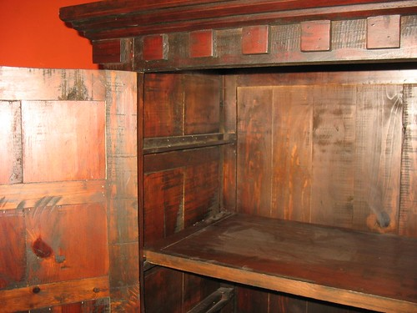

[This Photo](https://www.flickr.com/photos/40225188@N00/398761170) by Unknown Author is licensed under [CC BY-SA](https://creativecommons.org/licenses/by-sa/3.0/)

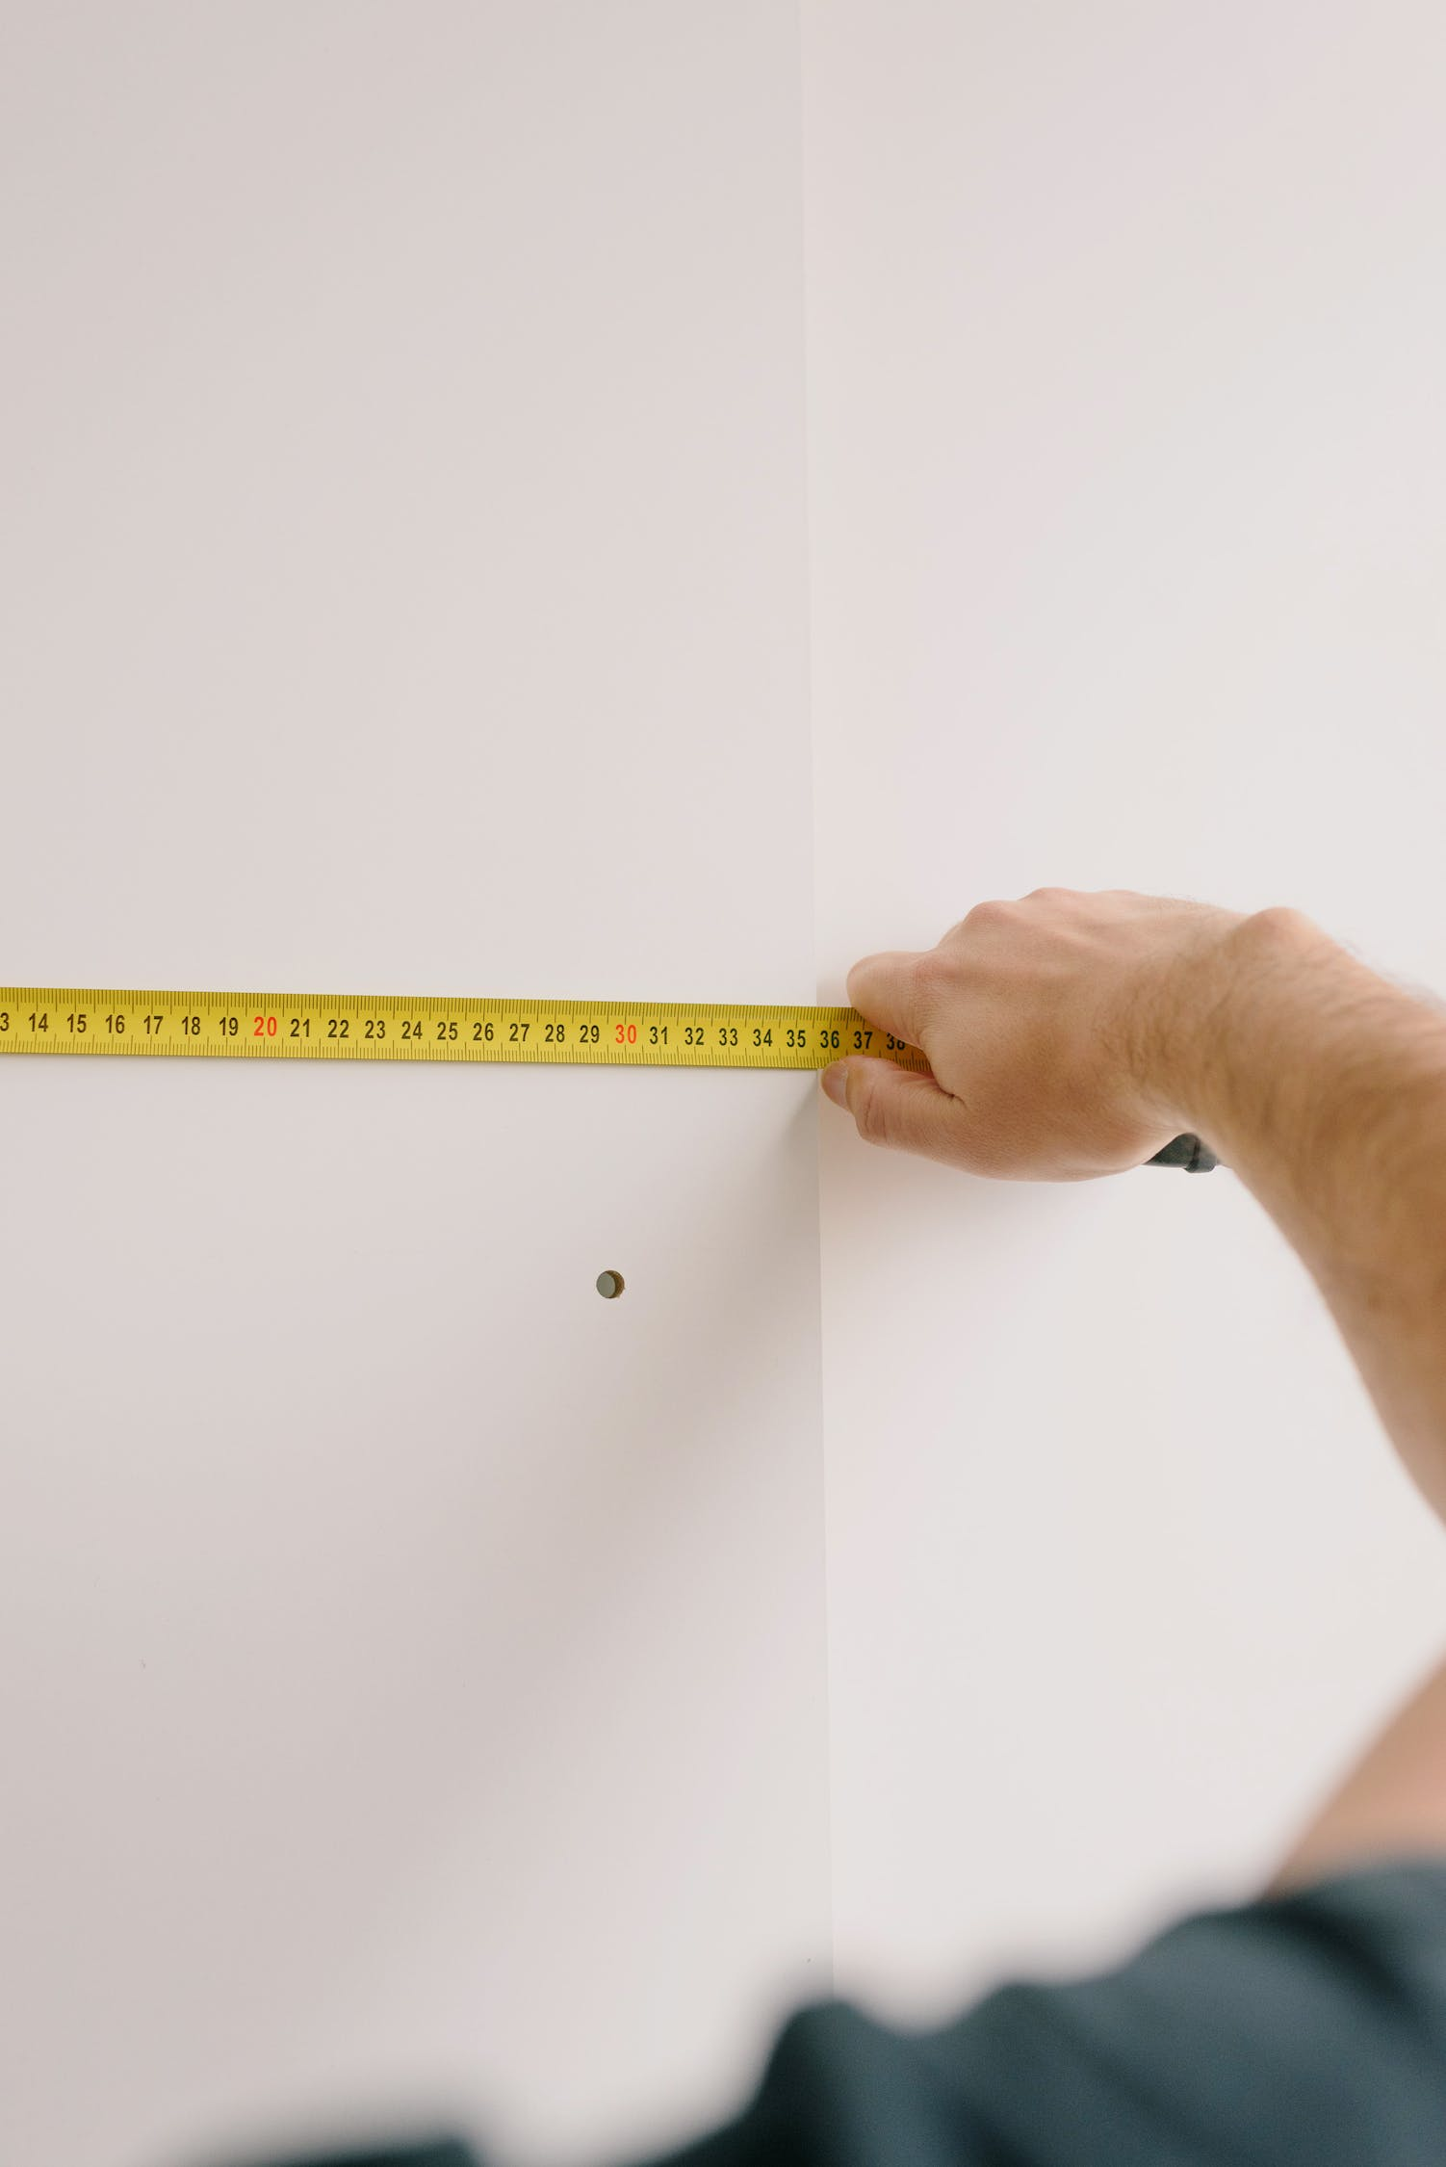

Figure 2

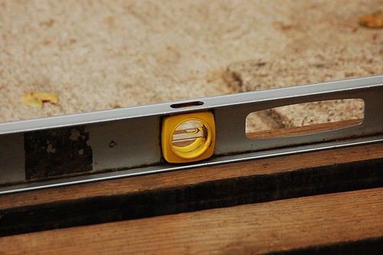

[This Photo](https://aminddivided.com/2011/05/) by Unknown Author is licensed under [CC BY-SA](https://creativecommons.org/licenses/by-sa/3.0/)

Figure 3

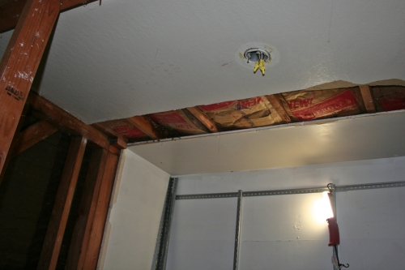

[This Photo](https://kavulak.net/tag/bathroom/) by Unknown Author is licensed under [CC BY-SA-NC](https://creativecommons.org/licenses/by-nc-sa/3.0/)

Figure 4

[This Photo](https://aminddivided.com/2011/05/) by Unknown Author is licensed under [CC BY-SA](https://creativecommons.org/licenses/by-sa/3.0/)

Figure 6

[This Photo](https://aminddivided.com/2011/05/) by Unknown Author is licensed under [CC BY-SA](https://creativecommons.org/licenses/by-sa/3.0/)

Figure 5

[This Photo](https://aminddivided.com/2011/05/) by Unknown Author is licensed under [CC BY-SA](https://creativecommons.org/licenses/by-sa/3.0/)

[This Photo](https://www.woodsybond.com/how-to-use-zircon-stud-finder/) by Unknown Author is licensed under [CC BY-ND](https://creativecommons.org/licenses/by-nd/3.0/)

Figure 8

[This Photo](https://pickupsomecreativity.blogspot.com/2012/06/cabinetsa-work-in-progress.html) by Unknown Author is licensed under [CC BY-SA-NC](https://creativecommons.org/licenses/by-nc-sa/3.0/)

Figure 7

[This Photo](http://diy.stackexchange.com/questions/13162/will-this-22-drawer-slide-replace-the-slide-mounted-to-my-18-drawer) by Unknown Author is licensed under [CC BY-SA](https://creativecommons.org/licenses/by-sa/3.0/)